**IA-2 Organic Solar Cells – Theory and Practice**

**Name: Pargat Singh Roll. No: 16010121045 Batch: A2 Division: A**

Welcome Mail



Quiz Grades

Final Quiz Score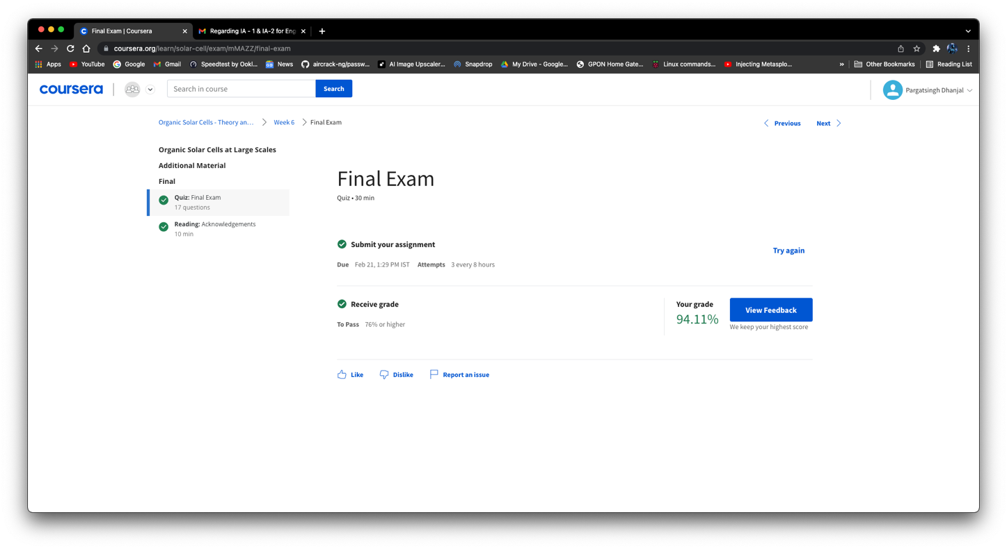

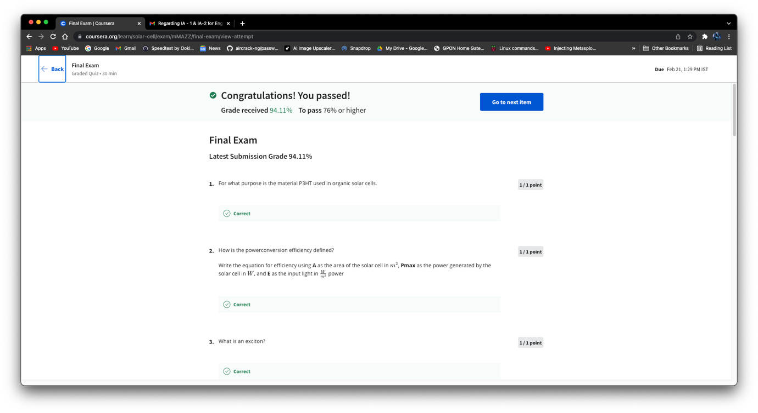

Course Completion Mail

